­Bank Management System

(SRS Report)

**Members:** Bashaar (2020-ag-6373)

Ahmad Sultan (2020-ag-6374)

**Team Guide:** Sir Salman Afsar



**University Name:** University of Agriculture Faisalabad  **Department:** Computer Science

**1. Introduction**

The name of our project is **Bank Management System** in which we can create a user account. The purpose of this website is to facilitate the user to see the transactions and to make deposit of cash and withdraw cash. Bank management provides processes and technology that help a company track and manage all their bank relationships by: Providing a single view of all accounts and activities with a bank, worldwide. This includes bank accounts, insurance, lines of credit, and foreign exchange.

**1.1 Purpose:**

This document details the software requirements for the Bank Management System. It defines what the problem is and what problems a complete solution must solve. The purpose of this system requirement specifications is to verify that all the specifications are correct and verified. This document also ensures that the software is traceable throughout its software development lifecycle.

**1.2 Scope of Project:**

* The scope of this project is that this reduces the requirement for manual labor and the automated tasks will be error-free as they will only work as they are programmed whereas doing work manually there is always a possibility of human error.
* The existing bank system is slow as every task is being performed by the human being and comparing the computer task speed with a computer is not fair. The complexity of this system is increased when an increase in the number of customers and with that there will be several transactions will be performed now everything needs to log in to a file for reference in the future which is simply not the kind of scenario we need at this time.
* Some improvements by executing the proposed system:
* More secure information will give a layer of security of authentication and authorization.
* Required very little manpower.
* Simplify the problem of editing.
* Maintain the clearance level by the hierarchy.
* The information will be secure from the different types of disasters as there will be an automatic backup system for the customer and bank information.
* Maintain data integrity Validate the manual calculations avoid calculation error.
* Safeguard data accuracy.
* More reliable and efficient.
* A more user-friendly interface.
* It can be easily accessible by every customer because its content is understandable by a normal person.
* It is based on a web application so we can easily access it from anywhere.

**1.3 Definition, Acronyms, and Abbreviations.**

NA –Not Applicable

PGS – Participatory Organic Guarantee System.

FR- Functional Requirements

SRS –System Requirement Study

**2.Functional Requirements**

|  |  |  |  |
| --- | --- | --- | --- |
| **Functional Req. ID #** | **Functional Req.**  **Name** | **Functional Requirement**  **Description** | **Business requirement** |
| FR-1.1 | Menu | After opening the website there is a menu option on the top of the page of the website. In the menu section there is a login option. | High |
| FR-1.2 | Log in | The user of the website has to login first to access the website completely. The user goes to the login option and enters his/her correct username and password to login to the website. If the user did not enter the correct password or username, it will show pop up alert on the screen. | High |
| FR-1.3 | Sign up | If the user is new on the website, then he/she must sign up first then he/she can make an account on the bank website. There will be some functionalities on the signup page that user should enter a valid email and a valid password that matches a specific format. | High |
| FR-1.4 | Account  (View) | After logging in the user can view the accounts created by him/her on the specific email. | High |
| FR-1.5 | Account  (Create) | After logging in the user can make an account on the banking website. He/she can view all accounts that are linked with the logged in username/email. | High |
| FR-1.6 | Account  (Delete) | The user can also delete an account if he/she does not need it anymore. | High |
| FR-1.7 | Transactions  (View) | The user can view the transactions made by him/her all along with history by going to the view transactions option. | High |
| FR-1.8 | Transactions  (Make) | The user can make any transaction of the required amount if he/ she wants to send cash to anyone. | High |
| FR-1.9 | Cash Deposit | The user can deposit cash of the required amount to the willing account. | High |
| FR-1.10 | Cash Withdrawal | The user can withdraw cash of the required amount from the account. The error will show up on the screen if the user enters the amount present int the account. | High |
| FR-1.11 | Contact Bar | User can contact the bank if he/she needs any help of any kind of the website. There will be a contact bar in which there are options for Facebook and Gmail. | High |
| FR-1.12 | Log out | User can log out of the website whenever he/she wants. There will be a logout option in the menu. | High |

**3. Non-Functional Requirements**

**1: Usability**

No matter the size of your business, you want your website to be easy to use. It takes about 0.05 seconds for user to figure out website. Usability is defined by how easily a user can achieve their goal in a single page visit.

**2: Security**

Depending on your business location, security also means complying with the customer data protection rules. It is also about different admin roles allowing you to control who can create, see, copy, change or delete information.

**3: Performance**

If your goal is increasing your website users, performance should be the priority. For good performance the home page should load in less than 4 seconds.

**4: Maintainability**

A maintainable system must be capable of being maintained cost effectively over the expected lifetime.

**5:** **Scalability**

It means that the system must be able to accommodate larger volumes (whether for users) over time. Today scalability can be achieved easily because of cloud based solutions.

**ER Diagram**

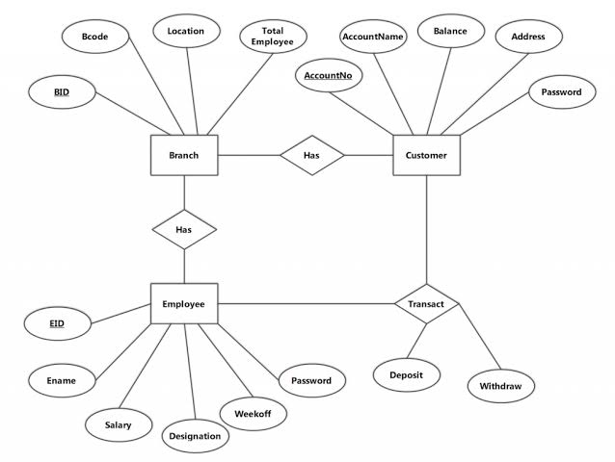

**Use Case Diagram**

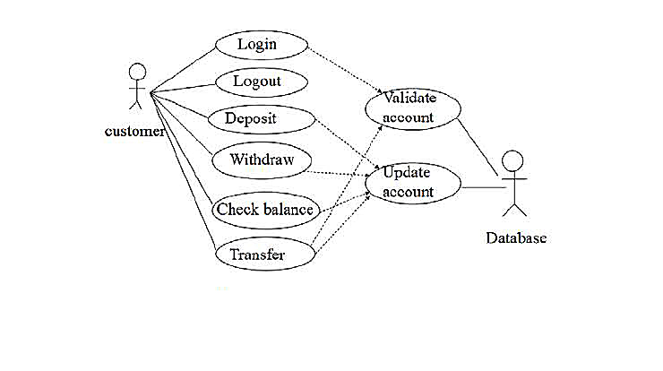

**Log in**

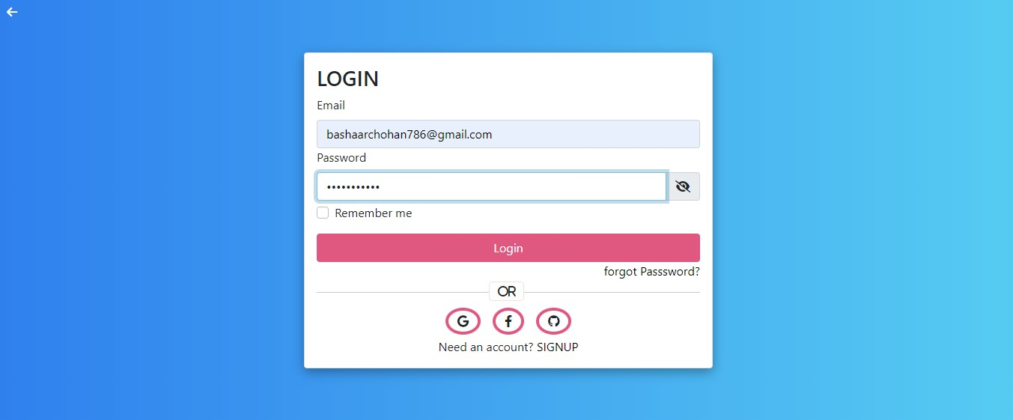

**Sign up**

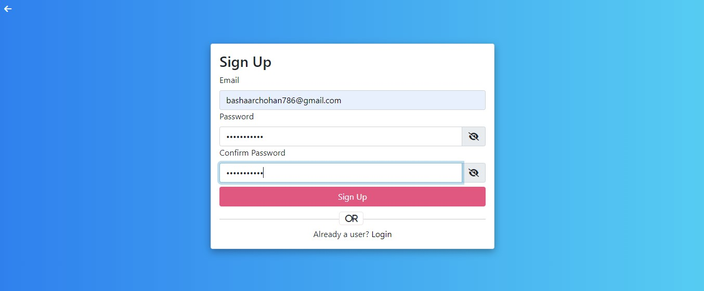

**Dashboard**

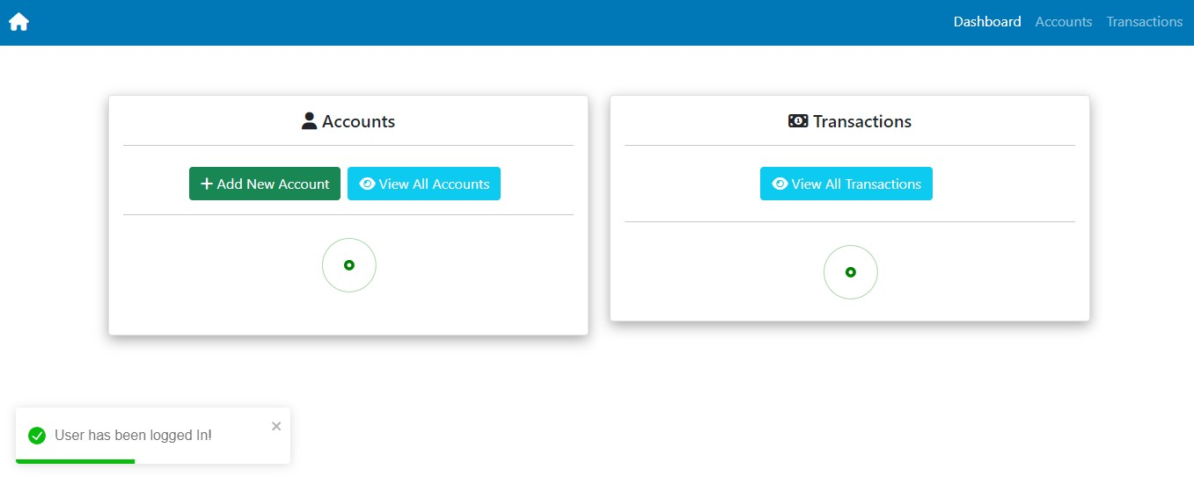

**Create Account**

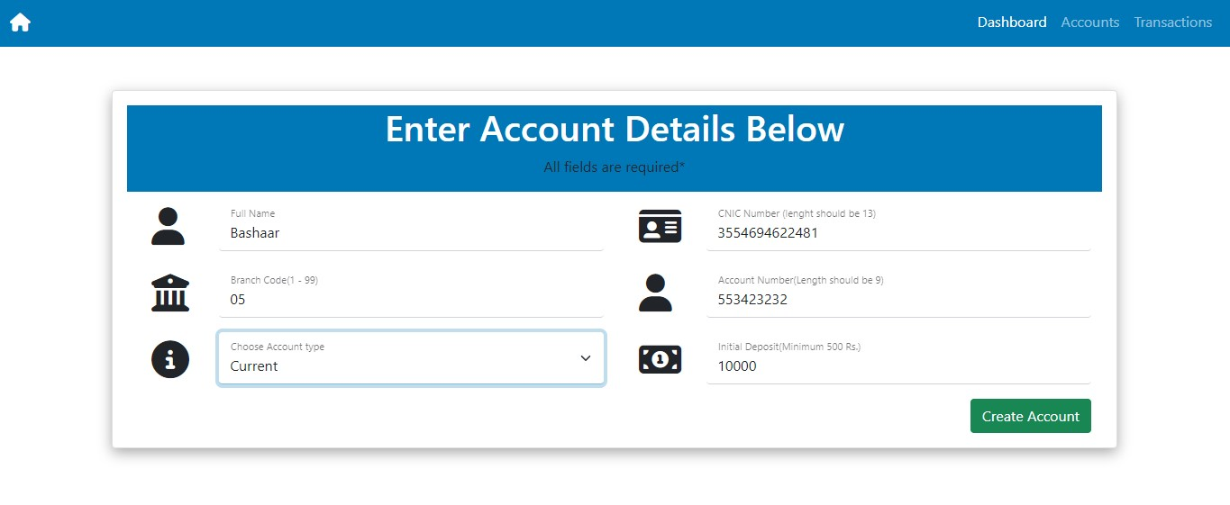

**View Accounts**

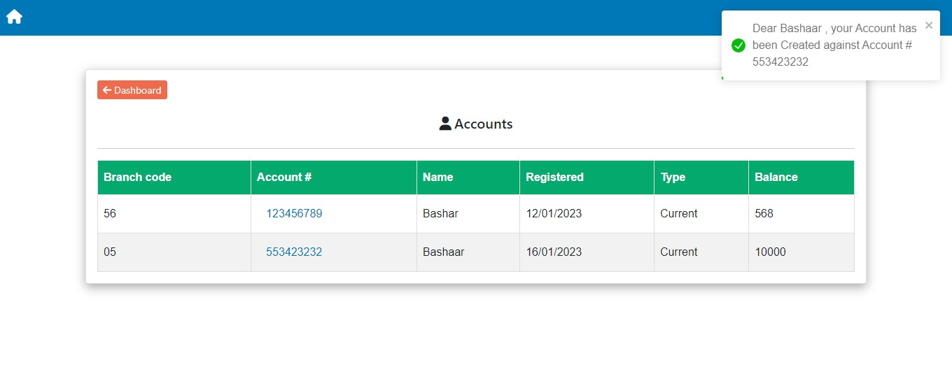

**View Transactions**

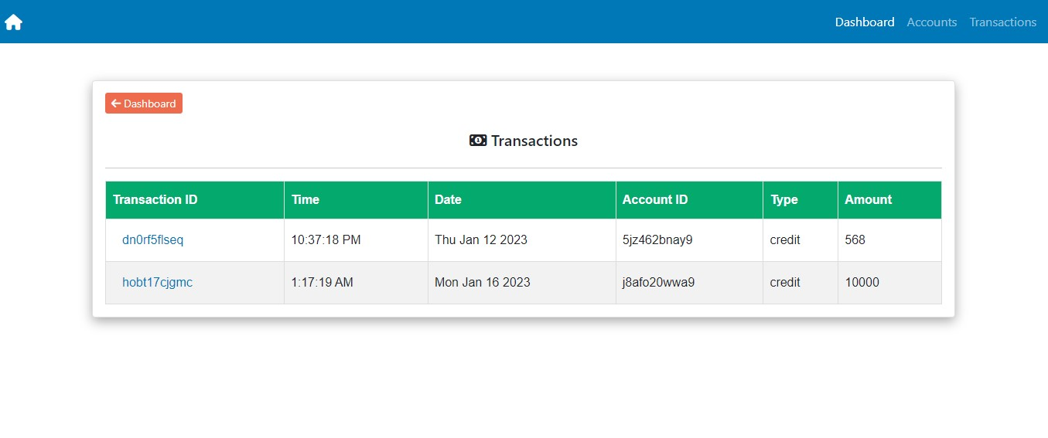

**Account Details**

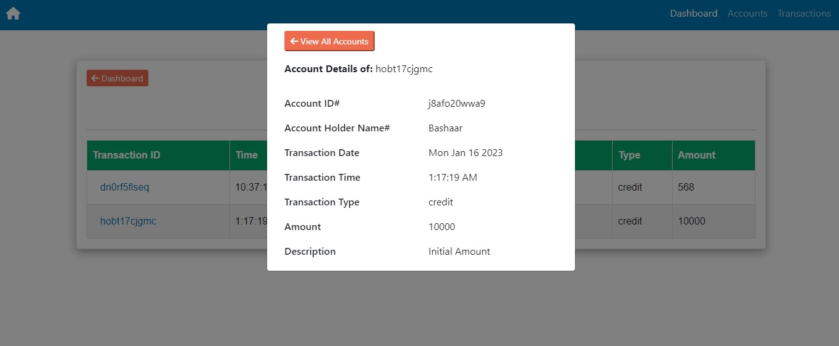

**Withdraw**

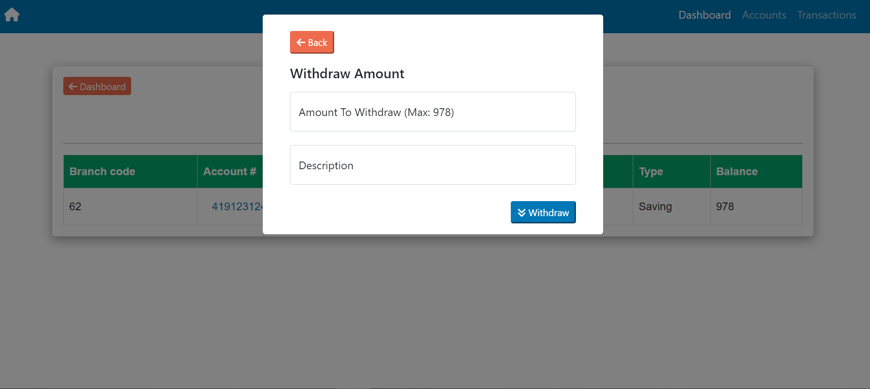

**Deposit**

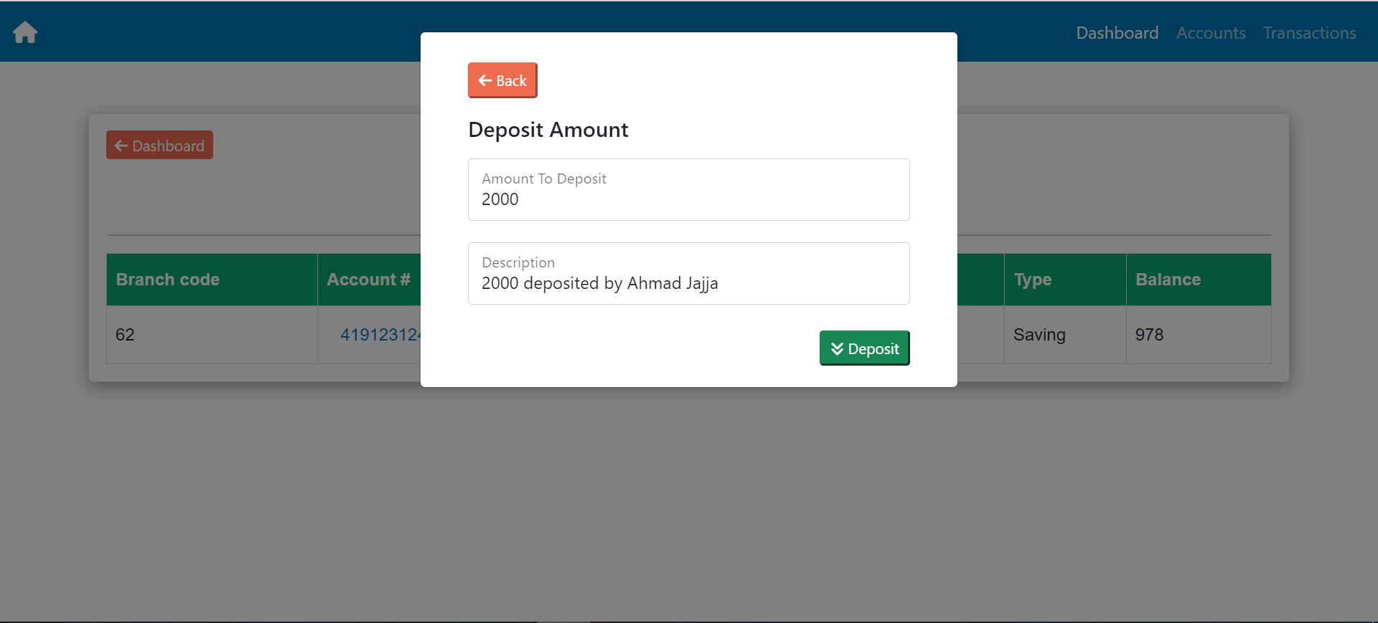

**Delete**

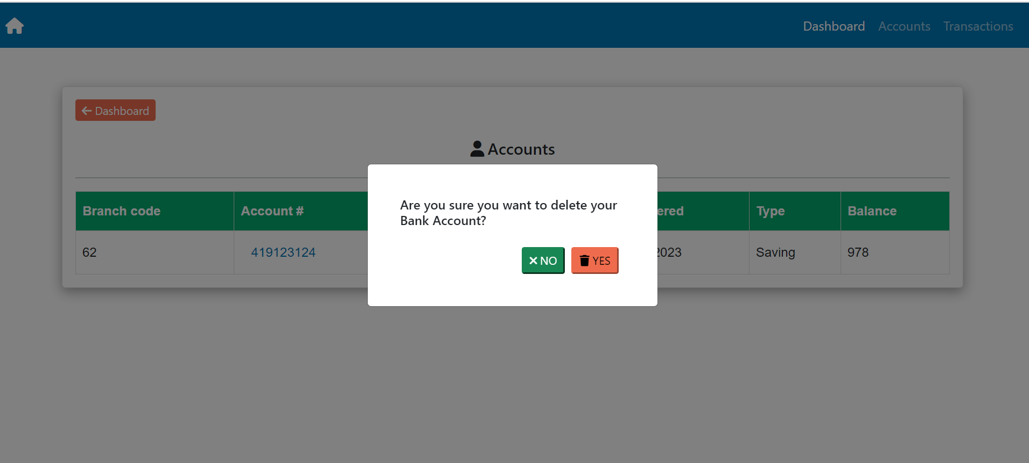

**Home**

